

SMART DISASTER RELIEF INVENTORY AND DISTRIBUTION MANAGEMENT SYSTEM USING C
Submitted in the partial fulfilment for the Course of
CSA0203-C PROGRAMMING
to the award of the degree of
BACHELOR OF ENGINEERING IN
ELECTRONS AND COMMUNICATION ENGINEERING
Submitted by
K. POORNA CHANDU (192312585)
M. HEMANTH REDDY (1923122534)
Under the Supervision of
Dr.S K. SARAVANAN

Saveetha Institute of Medical and Technical Sciences
Chennai - 602105

1. Problem Statement
During natural and man-made disasters such as floods, earthquakes, cyclones, landslides, forest fires, and industrial accidents, large quantities of relief resources need to be collected, stored, monitored, and distributed efficiently. Relief materials may include food, water, medicines, rescue equipment, transportation resources, clothing, and other essential supplies.
Managing these resources manually can lead to incorrect inventory records, shortage of essential materials, duplicate entries, inefficient distribution, and difficulty in identifying resources that require immediate replenishment.
The Smart Disaster Relief Inventory and Distribution Management System is developed using the C programming language to manage relief resources efficiently. The system maintains information about each resource, including its ID, name, category, available quantity, minimum required quantity, distribution centre, and priority.
The system provides functionalities for adding, updating, searching, sorting, analysing, allocating, merging, storing, and reporting relief resources. It also identifies resources as ADEQUATE, LOW, or CRITICAL based on their available quantity.
The system can therefore help disaster management teams maintain an organized inventory and make faster decisions regarding resource distribution and replenishment.
2. Objective
The main objective of the project is to develop a C-based disaster relief resource management system that can efficiently monitor and distribute resources during disaster situations.
• Maintain records of disaster relief resources.
• Categorize resources based on their type.
• Maintain the available quantity of each resource.
• Define the minimum quantity required for each resource.
• Identify resources with adequate, low, or critical stock levels.
• Allocate and distribute resources according to requirements.
• Search for resources using different parameters.
• Sort resources based on quantity, priority, category, or distribution centre.
• Analyse the overall availability of resources.
• Merge inventory records from another relief centre.
• Store inventory information permanently using files.
• Generate a disaster relief resource report.
• Demonstrate structures, pointers, functions, arrays, strings, recursion, sorting, and file processing in C.
3. Requirements and Environment Used
3.1 Hardware Requirements
• Processor: Intel Core i3 or equivalent
• RAM: Minimum 4 GB
• Storage: Minimum 100 MB free space
• Keyboard and monitor
• Standard desktop or laptop computer
3.2 Software Requirements
• Operating System: Windows / Linux / macOS
• Programming Language: C
• Compiler: GCC / MinGW / Clang
• IDE: Visual Studio Code / Code::Blocks / Dev-C++ or any C-compatible IDE
• Terminal or Command Prompt
3.3 C Concepts Used
C Concept | Application in Project
Structures | Stores resource records
Arrays | Stores multiple resource records
Pointers | Efficient resource access and modification
Functions | Divides the program into modules
Decision Making | Resource status and validation
Loops | Processing inventory records
Strings | Resource names, categories and centres
Recursion | Recursive resource analysis
Sorting | Sorting inventory records
File Handling | Saving, loading, merging and reporting

4. Design / Proposed Solution
The proposed system consists of a centralized inventory management program where relief resources are represented using a structure. Each resource record contains Resource ID, Name, Category, Quantity, Minimum Required Quantity, Distribution Centre, and Priority.
4.1 Major Modules
Module | Description
Resource Addition | Allows users to add a resource after checking for duplicate Resource IDs.
Resource Updating | Updates quantity, minimum required quantity, and priority using Resource ID.
Resource Display | Displays all resources in a tabular format with their current status.
Resource Search | Searches by Resource ID, Name, Category, or Distribution Centre.
Resource Sorting | Sorts by quantity, priority, category, or distribution centre using Bubble Sort.
Resource Allocation | Distributes a specified quantity and deducts it from available inventory.
Resource Analysis | Calculates total units and counts adequate, low, and critical resources.
Merge Relief Centre Records | Reads merge_resources.dat and adds unique Resource IDs.
File Storage | Saves and loads inventory using resources.dat.
Report Generation | Creates disaster_report.txt containing inventory and replenishment information.

4.2 Resource Categories
Category | Examples
Food and Water | Rice, biscuits, drinking water, milk
Medicine | First-aid kits, antibiotics, medical supplies
Rescue Equipment | Ropes, stretchers, life jackets
Transportation | Boats, trucks, ambulances
Shelter | Tents, blankets, temporary shelters
Clothing | Clothes, shoes, protective wear
Communication | Radios, satellite phones
Other | Additional emergency resources

5. Algorithm / Pseudocode / Flowchart
5.1 Overall Algorithm
1. Start the program.
2. Load previously stored inventory records from resources.dat.
3. Display the main menu.
4. Accept the user's choice.
5. Perform the selected operation: Add, Update, Display, Search, Sort, Allocate, Analyse, Merge, Save, or Generate Report.
6. Return to the main menu after the operation.
7. Continue until the user selects Exit.
8. Save the inventory before terminating.
9. End the program.
5.2 Resource Status Algorithm
IF quantity <= minimum / 2
Status = CRITICAL
ELSE IF quantity < minimum
Status = LOW
ELSE
Status = ADEQUATE
Available Quantity | Status
0–50% of minimum | CRITICAL
Above 50% but below minimum | LOW
At or above minimum | ADEQUATE

5.3 Resource Allocation Algorithm
START
Read Resource ID.
Search for Resource ID.
IF resource does not exist, display “Resource not found”.
Display available quantity.
Read quantity to distribute.
IF quantity <= 0, display “Invalid quantity”.
ELSE IF requested quantity > available quantity, display “Insufficient stock”.
ELSE subtract distributed quantity and display successful distribution.
Check remaining stock and display LOW or CRITICAL warning when applicable.
END
5.4 File Processing Algorithm
START
Open resources.dat.
IF file exists, read count and resource records.
ELSE display “No previous inventory found”.
Run inventory management system.
When user exits, save count and all resource records to resources.dat.
Close file.
END
5.5 Flowchart
START
↓
Load Inventory from File
↓
Display Main Menu
↓
Enter User Choice
↓
Perform Selected Operation
↓
Operation Complete
↓
Choice = 0?
├── NO → Display Main Menu
└── YES → Save Inventory → END
6. Implementation / Source Code
The system is implemented in C using a structure-based approach. The Resource structure stores all information related to a relief resource. An array of 100 Resource records is maintained. The program is divided into functions for each major operation, making the implementation modular and easier to test and maintain.
The main functions are:
• addResource()
• updateResource()
• displayResources()
• searchResource()
• sortResources()
• allocateResource()
• analyseResources()
• mergeResources()
• saveToFile()
• loadFromFile()
• generateReport()
• recursiveAnalysis()
• findByID()
• getStatus()
Example structure used in the implementation:
typedef struct {
int id;
char name[50];
char category[30];
int quantity;
int minimum;
char centre[50];
int priority;
} Resource;
Compilation using GCC:
gcc disaster_relief_inventory.c -o disaster_relief_inventory
Execution on Linux/macOS:
./disaster_relief_inventory
Execution on Windows:
disaster_relief_inventory.exe
The complete source code supplied for this project can be placed after this section as an appendix if required by the institution.
7. Test Cases and Expected/Actual Results
Test Case | Input / Operation | Expected Result | Actual Result
TC01 | Add new resource | Resource added  successfully | Passed
TC02 | Add duplicate ID | Duplicate ID rejected | Passed
TC03 | Display resources | All records displayed | Passed
TC04 | Update existing resource | Resource information updated | Passed
TC05 | Search by ID | Matching resource  displayed | Passed
TC06 | Search by category | Matching resources  displayed | Passed
TC07 | Search by centre | Matching resources  displayed | Passed
TC08 | Sort by quantity | Resources sorted by  quantity | Passed
TC09 | Sort by priority | Resources sorted by  priority | Passed
TC10 | Distribute valid quantity | Quantity reduced  successfully | Passed
TC11 | Distribute more than available | Insufficient stock  message | Passed
TC12 | Quantity becomes critical | Critical warning  displayed | Passed
TC13 | Analyse inventory | Statistics displayed | Passed
TC14 | Save inventory | Data saved to file | Passed
TC15 | Restart program | Previous data loaded | Passed
TC16 | Generate report | Report file created | Passed
TC17 | Merge records | Unique records added | Passed
TC18 | Merge duplicate records | Duplicates skipped | Passed

Sample Test Data
ID | Resource | Category | Quantity | Minimum | Centre | Priority
101 | Rice Bags | Food and  Water | 500 | 200 | Chennai | 1
102 | Drinking  Water | Food and  Water | 1000 | 500 | Chennai | 1
103 | First Aid Kit | Medicine | 80 | 100 | Madurai | 2
104 | Life Jackets | Rescue  Equipment | 30 | 100 | Kochi | 1
105 | Rescue Boat | Transportatio n | 5 | 10 | Chennai | 1

For Resource 103, quantity 80 is below the minimum 100 but above half of the minimum, so the status is LOW. For Resource 104, quantity 30 is below half of 100, so the status is CRITICAL.
8. Execution Screenshots / Output
The following screenshots should be captured after executing the program and inserted into the final report: 10. Main Menu – showing all system options.
11. Adding a Resource – showing input fields and successful addition.
12. Display Resources – showing the inventory table and status values.
13. Resource Allocation – showing successful distribution and stock warning.
14. Resource Analysis – showing total units and counts of adequate, low, and critical resources. 15. Report Generation – showing successful creation of disaster_report.txt.
16. Generated Report – showing the contents of disaster_report.txt.
Sample Main Menu
==============================================
SMART DISASTER RELIEF INVENTORY SYSTEM
==============================================
1. Add Resource
2. Update Resource
3. Display Resources
4. Search Resource
5. Sort Resources
6. Allocate/Distribute Resource
7. Analyse Resource Availability
8. Merge Relief Centre Records
9. Save Inventory
10. Generate Report
0. Exit
Enter your choice:
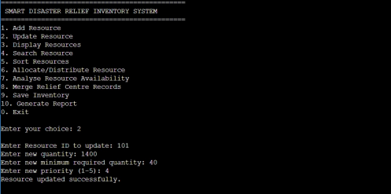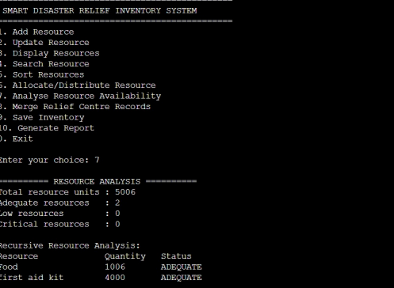
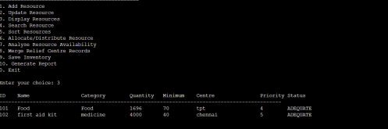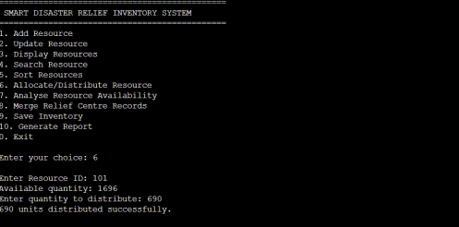
9. Analysis and Discussion
The developed system provides an organized method for managing disaster relief resources. The use of a structure allows different attributes of each resource to be stored together.
The pointer concept is demonstrated through functions such as findByID() and resource updating. Pointers allow direct access to structure records without creating unnecessary copies.
Functions divide the program into smaller modules. This improves readability, maintainability, and reusability. Decision-making statements are used for input validation and resource status classification, while loops are used for searching, displaying, sorting, analysis, and file processing.
Recursion is demonstrated through recursiveAnalysis(), which processes each resource sequentially. Bubble Sort is used to arrange resources according to quantity, priority, category, or distribution centre.
File handling provides data persistence. The inventory can be saved to resources.dat and loaded when the application starts. The merge functionality allows inventory records from another relief centre to be incorporated while skipping duplicate Resource IDs.
The allocation functionality is important during emergencies because distribution changes the available stock. The system immediately checks the remaining quantity and warns the user if the resource becomes LOW or CRITICAL.
Overall, the project demonstrates how fundamental C programming concepts can be combined to solve a practical disaster management problem.
10. Conclusion
The Smart Disaster Relief Inventory and Distribution Management System using C successfully provides a computerized solution for managing disaster relief resources. The system allows users to add, update, display, search, sort, analyse, allocate, merge, save, and report resource information.
The project demonstrates important C programming concepts such as structures, arrays, pointers, functions, loops, decision-making, strings, recursion, sorting, and file handling. It can be applied to floods, cyclones, earthquakes, landslides, forest fires, industrial accidents, and other emergency situations.
Although the current implementation is console-based, it provides a strong foundation for future development. Future versions could include a graphical user interface, database connectivity, GPS-based distribution tracking, real-time updates, automated notifications, multiple-user access, and web-based monitoring.
Thus, the project demonstrates how C programming can be applied to develop a practical and useful solution for emergency resource management.
11. Individual Contribution of Group Members
Group Member | Contribution
Member 1 | Problem identification, system design, structure definition, resource addition and updating.
Member 2 | Resource display, search functionality, and sorting operations.
Member 3 | Resource allocation, stock-status checking, and resource analysis including recursive analysis.
Member 4 | File processing, inventory merging, report generation, testing, and documentation.
All Members | Debugging, integration, testing, screenshots, and final report preparation.

Note: Replace Member 1, Member 2, etc. with the actual names of group members and adjust contributions according to the work performed.
12. References
17. E. Balagurusamy, Programming in ANSI C, McGraw Hill Education.
18. Yashavant Kanetkar, Let Us C, BPB Publications.
19. Brian W. Kernighan and Dennis M. Ritchie, The C Programming Language, Prentice Hall. 20. GCC documentation and C compiler references.
21. Standard C Library documentation for stdio.h, stdlib.h, and string.h.
22. Class notes and course materials related to C programming, structures, pointers, functions, recursion, sorting, and file handling.

